1. **Total Revenue**

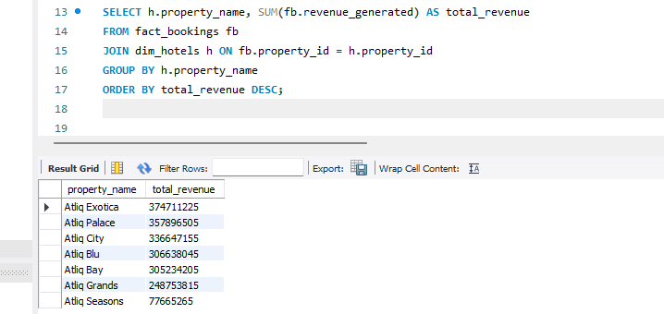

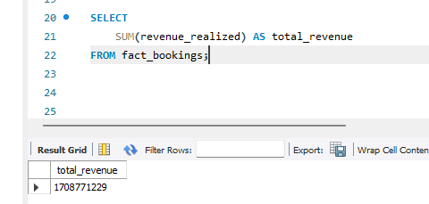

1. **Occupancy** 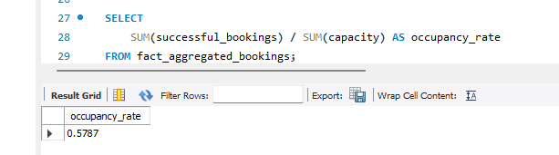

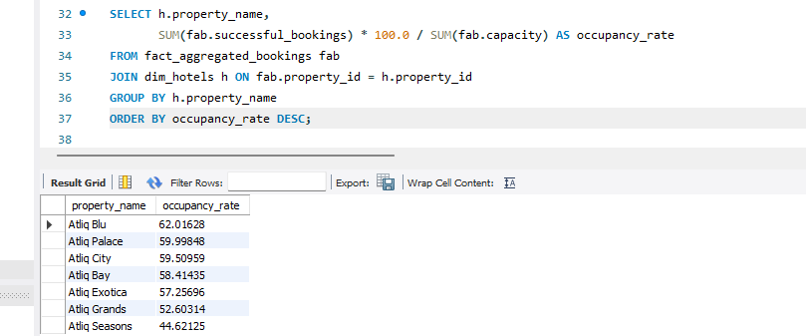

1. **Cancellation Rate**

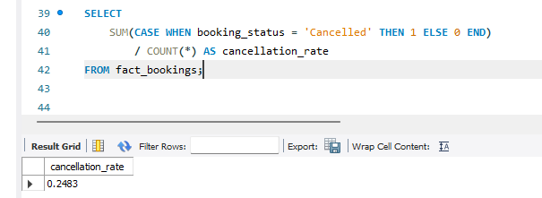

1. **Total Booking**

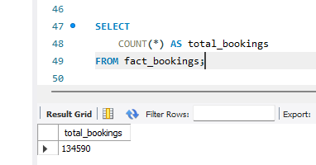

1. **Utilize capacity**

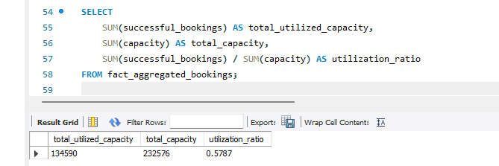

1. **Trend Analysis**

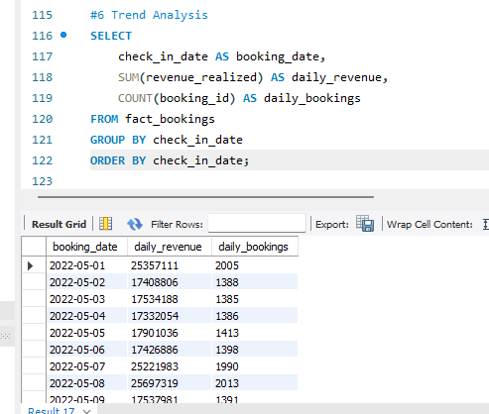

1. **Weekday & Weekend Revenue and Booking**

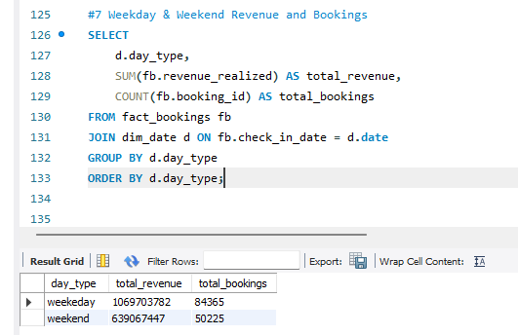

1. **Revenue by State & hotel**

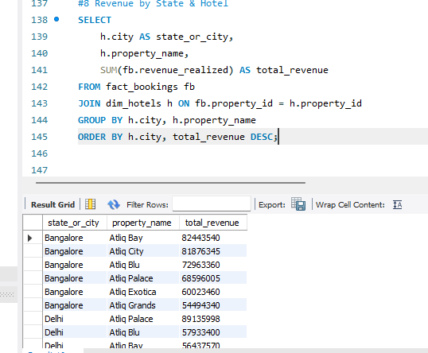

1. **Class Wise Revenue**

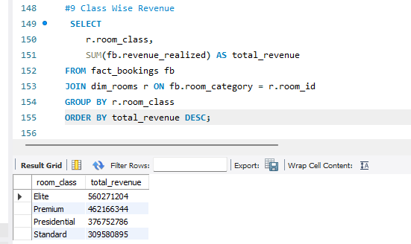

1. **Checked out cancel No show**

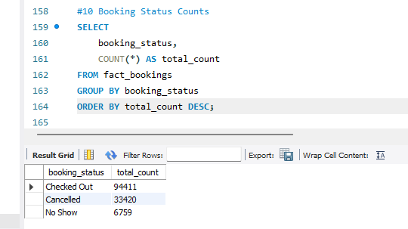

1. **Weekly trend Key trend (Revenue, Total booking, Occupancy)**

